Let’s all meet Mr. Reinhardt

What is Mr. Reinhardt’s full name? _____________________________



________________________! This organization has more country members than the UN, and it is the governing body of Mr. Reinhardt’s favorite sport. What is it?

Mr. Reinhardt can solve a Rubik’s Cube in how many seconds?

_______



How many of these has Mr. Reinhardt won in his life time? ______________
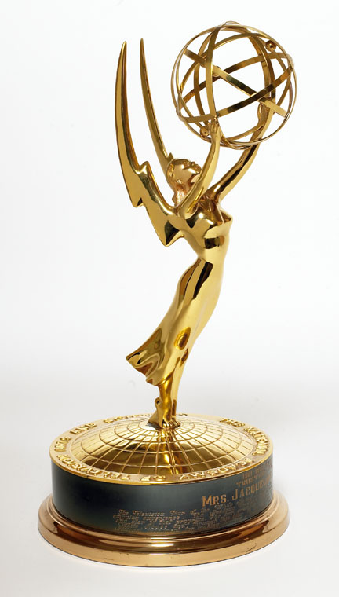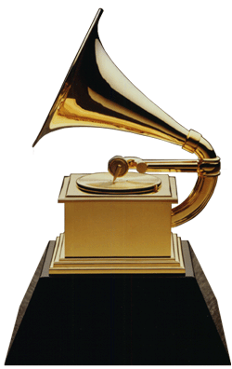

For which college did Mr. Reinhardt become the GNAC conference champion in the Javelin?

_________________________________


